
SANTA BARBARA CITY COLLEGE
Student Finance

PROCEDURE

Procedure Regarding: Understanding Budget Codes and Using Simpler
- Understanding the Budget Code (FOAPAL) String | Page 1
- Accessing Simpler | Page 4
- Finding your fund, organization, account, program, and/or activity numbers based on the name | Page 6
- Finding Balances in Simpler | Page 8
- Learn how to monitor your departmental budgets and other financial information | Page 10
- Save Reports as a Template | Page 12

Step 1: The Budget Code (FOAPAL) String
This string of numbers is critical in assigning revenue and expenditures to the correct organization and identified account type. These assignments allow departments and interested parties track their actual expenses against their budget and monitor the transactions to ensure all postings are accurate.
Fund  Number | Organization Number | Account Number | Program Number | Activity Number | Location Number
5 numbers | 4 numbers | 6 digits | 6 numbers | 6 numbers | 6 numbers

Types of FUNDS:

District Funds:
  - All District funds are managed by the District, approved by the Board, and require governmental accounting compliance.
  - General Unrestricted Funds begin with 11*
    - The revenue posted to the general unrestricted fund, also called the UGF, are from student enrollment fees and state and local apportionment.
    - The expenditures are for general operation costs.
    - Budgets are provided by Fiscal Services and are to be strictly adhered to.
  - General Restricted Funds begin with 12*
  - Grant and Categorical Restricted Funds begin with 12*
  - Equipment Funds begin with 41*
  - Construction Funds begin with 43*

Auxiliary (Enterprise), Trust, Financial Aid and Club Funds
  - Food Service Funds begin with 32*
  - Bookstore Funds begin with 51*
  - Associated Student Government Funds begin with 71* and 72*
    - All budgeting activities, collected and/or assigned revenues and monies expended must meet Ed Code and the Bylaws of the Associated Student Government. The primary source of income is through the Student Activity Pass and Student Representation fees collected at student registration.
  - Federal Financial Aid Funds begin with 74*
  - Scholarship & Grant Funds begin with 75*
    - All scholarships are administered by the Financial Aid office.
  - School of Extended Learning begins with 77*
  - Trust Funds begin with 79*
    - Revenue is collected by Donor contributions, sales and Foundation contributions. These monies are not District monies and the college is merely acting as a fiduciary agent of these funds.
    - Many Departments will open a Trust Fund to conduct extracurricular events that are not course-specific and/or to provide stipends to students. These monies are not District monies as they are self-sourced and exist for the purpose of the extracurricular.
  - Club Funds begin with 81*
    - Revenue is collected by Donors contributions or sales, such as Bake Sales. These monies are not District monies and the college is merely acting as a fiduciary agent of these funds.

ORGANIZATION: The Org code is used to segregate and sort charges by individual departments.

District

The Org is required for use in all District transactions within the restricted and unrestricted general fund.

Org is also known as Department.

Budgets are assigned at the Org level.

Expenditures require an Org assignment to credit against the established budget and assess overall departmental costs.

For example, Communications Department is 4859 and Fiscal Services is 4212.

Trust & Auxiliary

Org codes are never utilized as these funds are not specific to any single org, rather they are individually/group created and managed. There are instances where trust funds exist for the benefit of a given department, but again, this department coding should not be used as it is not a formal departmental budgeting entity.

These codes will remain “0000” for all Trust and Club funds (as they are not department specific funds and the fund number adequately denotes the specific use.
ACCOUNT: These codes are required and specific to the type of expenditure, such as non-instructional supplies (451000) or travel and conference (522000), etc. ALL funds, regardless of District, Grant, Trust or otherwise, are required to assign the Account Code to the specific expenditure.
- The college uses a specific “Chart of Accounts” and these accounts specify what kind of expenditure and/or revenue to which the transaction should be associated. For example, if the expense is for a consultant (account number 511000), then this number will be used, regardless of the fund or organization for which the expenditure is coded.
- Account codes are specific to the type of expenditure, such as non-instructional supplies (451000) or travel and conference (522000), etc.
- District Example: A purchase by Fiscal Services at the Bookstore for 10 reams of paper would be assigned 11000 - 4212 - 451000 – 672000. The account code for non-instructional supplies is 451000. This is combined with Fiscal Services org and program number.
- Trust Example: The Legacy Project Trust Fund receives money from SBCC Foundation would be assigned 799339 - 0000 - 882000 – 000000. Monies received by the Foundation are assigned Account Code 882000. The trust fund number is 799339 specific for The Legacy Project and since this is a trust fund, no org nor program code are listed.
PROGRAM:

District
  - These codes are specific to the fund, org and account. Not all use them. Please refer to your budget manager for specifics.

Trust & Auxiliary

These codes will remain “000000” for all Trust and Club funds (as they are not department specific funds and the fund number adequately denotes the specific use.

ACTIVITY:

District
  - These codes are specific to the fund, org and account; not all use them. These are assigned by Fiscal Services. Please refer to your budget manager for specifics.

Trust & Auxiliary

These codes will remain “000000” for all Trust and Club funds (as they are not department specific funds and the fund number adequately denotes the specific use.

LOCATION:

District
  - These codes are specific to the fund, org and account; not all use them. These are assigned by Fiscal Services. Please refer to your budget manager for specifics.

Trust & Auxiliary

These codes will remain “000000” for all Trust and Club funds (as they are not department specific funds and the fund number adequately denotes the specific use.

Full Budget Code (FOAPAL) string examples:

 | General Unrestricted  (Requires Budget) | Fund Number | Organization Number | Account Number | Program Number | Activity Number | Location Number
 | General Unrestricted  (Requires Budget) | 11000 | 1900 | 451000 | 110100 | * | *

 | General Restricted  (Requires Budget) | Fund Number | Organization Number | Account Number | Program Number | Activity Number | Location Number
 | General Restricted  (Requires Budget) | 12000 | 1900 | 451000 | 110100 | * | *

 | General  Restricted  (Requires Budget) | Fund Number | Organization Number | Account Number | Program Number | Activity Number | Location Number
 | General  Restricted  (Requires Budget) | 12000 | 1900 | 451000 | 110100 | * | *

 | Trust Fund | Fund Number | Organization Number | Account Number | Program Number | Activity Number | Location Number
 | Trust Fund | 79010 | 0000 | 451000 | 000000 | (NA) | (NA)

 | Club Fund | Fund Number | Organization Number | Account Number | Program Number | Activity Number | Location Number
 | Club Fund | 81010 | 0000 | 451000 | 000000 | (NA) | (NA)

Step 2: Accessing Simpler

Go to www.sbcc.edu
- Select the Pipeline Hyperlink


Log in to PIPELINE with the credentials provided to you
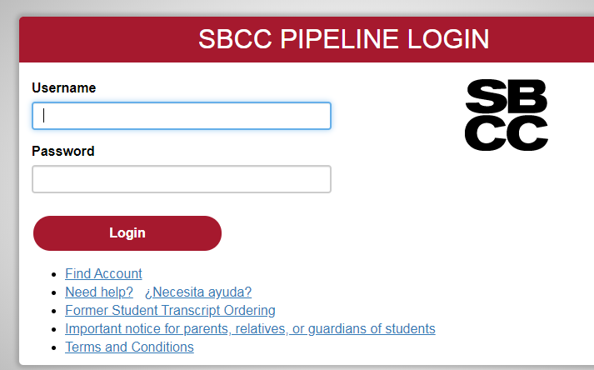

Select EMPLOYEE tab
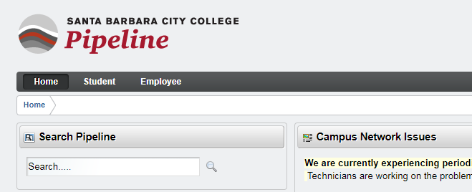
- Select RESOURCES tab
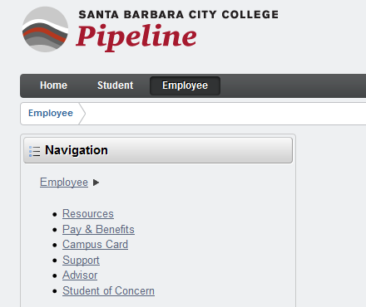

- Select SIMPLER FINANCIAL REPORTS
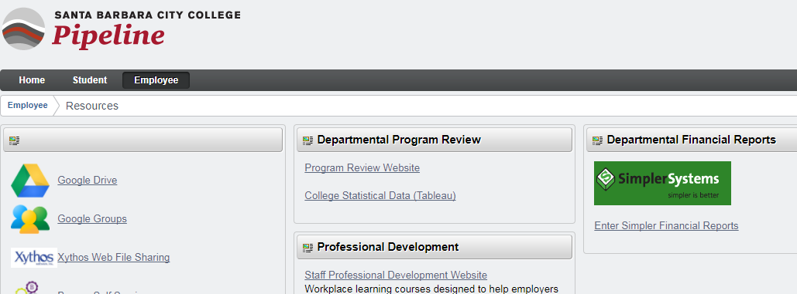

Step 3: Basic Simpler Systems Search functions including wild card usage.

Search for an existing fund, organization, account, program, and/or activity, for which you know the name but not the number.

Query Notes:
- Asterisks are used as wild cards when searching through Simpler.
- Query is not case sensitive
- Searching partial words or numbers is an effective way to find your fund/org/account/program.

- Go to CHART OF ACCOUNTS TABLES
- Select the Category for which you would like to research (i.e. Fund, Org, Account, etc)

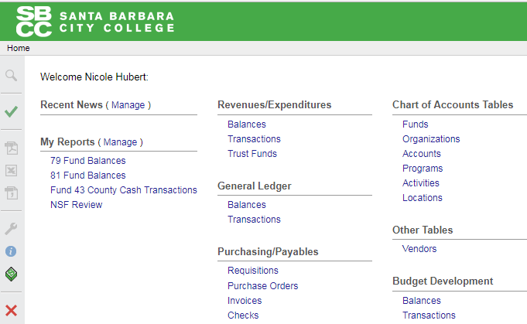

COMPLETE THE QUERY with any information you have, whether it is a partial fund number or partial fund name:
- CODE – The Fund/Org/Account Number
- TITLE – Type in letters or full word of your Fund/Org/Account

Query Example: Looking for “The Legacy Project” but unsure of the actual fund name.
- Query the term “legacy” by using asterisks at the beginning and end of legacy to ensure a search for the word anywhere in a title.
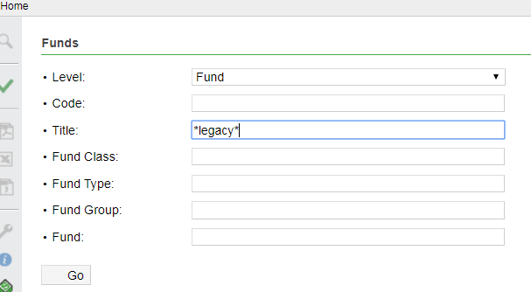

- Select GO
- Fund found: The Legacy Project, Fund #799339

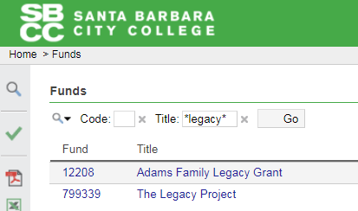

The remaining instructions are specific to TRUST FUNDS

Step 4: Finding BALANCES in Simpler.
- Under REVENUE/EXPENDITURES section
- Select Trust Funds
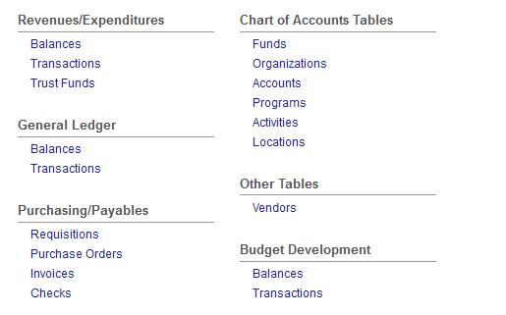
- Select As Of Date by selecting the “…” box for a drop down menu:
  - Search for “This Month End” for current Fund Balance
  - Search “Last Fiscal Year End” to view closing balance on June 30th.
- Select OK

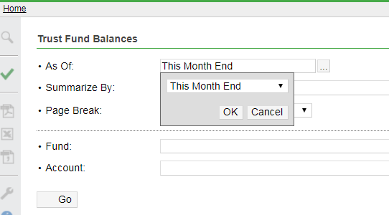

- Select Summarize By selecting the “…” box for a drop down menu:
  - Change “Account” to “Fund” by using the drop down menu
- Select OK
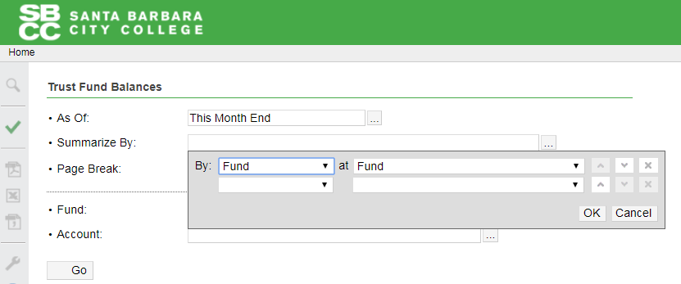

- For FUND, enter the Fund Number
- Select GO

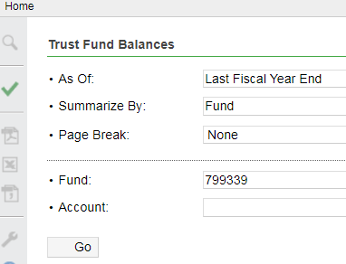

- Example:
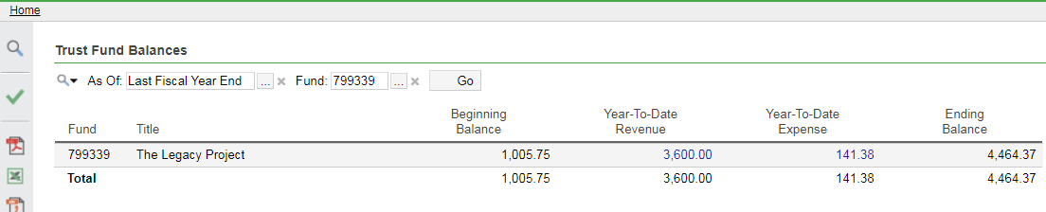
  - Data is reported by Fiscal Year on this report.
    - In this example, the Beginning Balance is the balance on June 30th of the prior year (Last Fiscal Year).
  - The Year to Date Revenue are be all monies deposited or transferred into your fund in the current fiscal year (since July 1st).
  - The Year to Date Expense will be all monies paid out of, or transferred out of your fund, in the current fiscal year (since July 1st).
  - The Ending Balance is the fund balance as of today.

Step 5: Finding Transactions in Simpler
- Under Revenues / Expenditures section
- Select Transactions

- Select From/To: by selecting the “…” box for a drop down menu:
  - Search for the date range in which you would like to review your transactions.
  - Possible options include, but are not limited to:
    - Current Month Range - FROM: “This Month Begin” / TO: “This Month End” for transactions within this calendar month
    - Current or last Fiscal Year Range - FROM: “This Fiscal Year Begin” / TO: “This Fiscal Year End”
    - Specific Month Ranges - FROM: “2/1/2020” / TO: “3/1/2020”
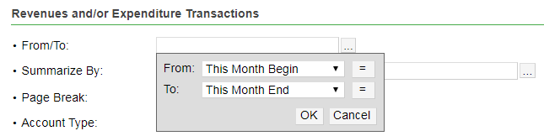
- Select OK

- Select Summarize by selecting the “…” box for a drop down menu:
  - Change “Account” to “Fund” by using the drop down menu
  - Then add “Account” to the second line
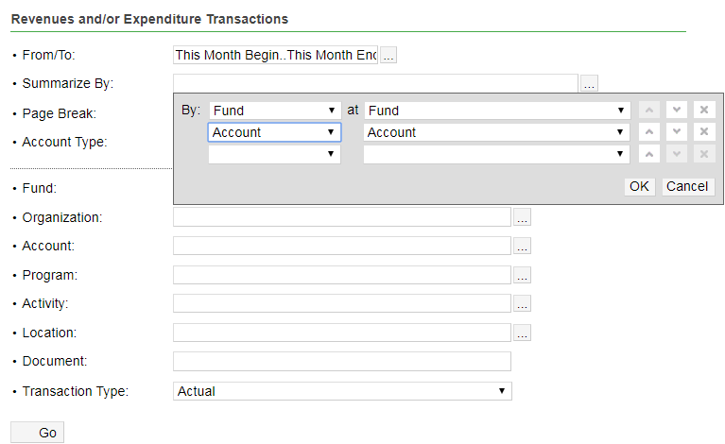
- Select OK

- For FUND, enter the Fund Number

- Select GO
  - The data returned will list all revenue and expenditure line items for the Fund listed and the timeframe requested:

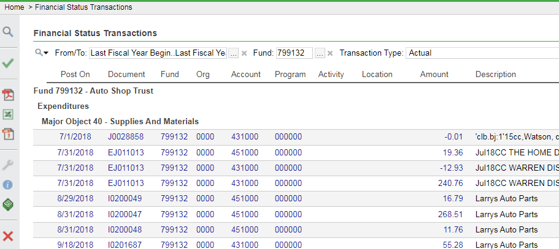

Step 6: Save Reports as a Template, also called a “Shortcut”
- To save a report you commonly use, whether fund balance, fund expenditures, or otherwise, pull up the preferred report so all data that you are looking to have is prepared.
- Select the green “Check box” on the left side of your Simpler screen

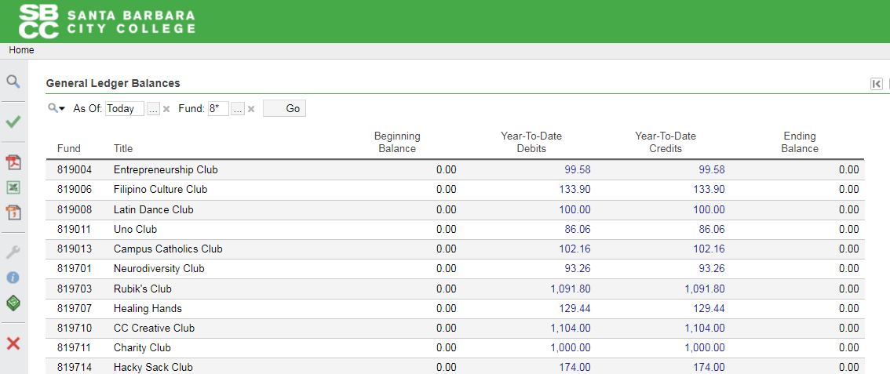

- Name your Report/Shortcut
- Find your name in the list of “Users”
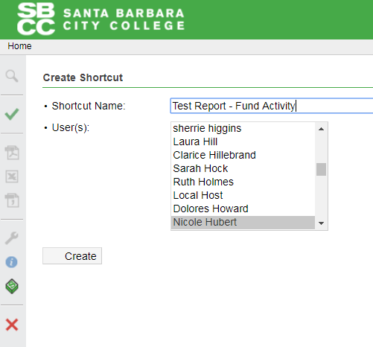

- Select Create
  - Your report will now be reflected under the “My Reports” section on your Simpler homepage.

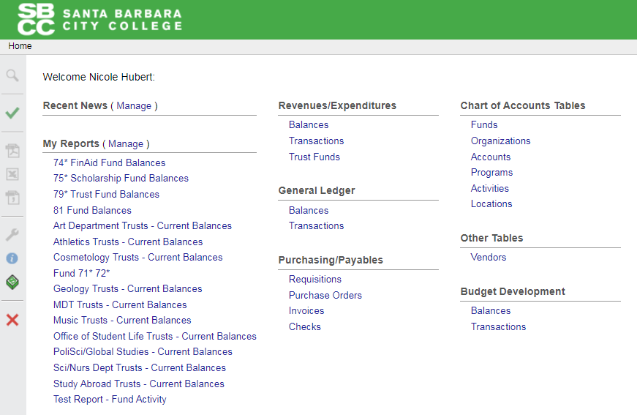

For additional assistance with Simpler access and saved reports, contact Lisa Kellogg-Saunders, in Accounting, for assistance.

